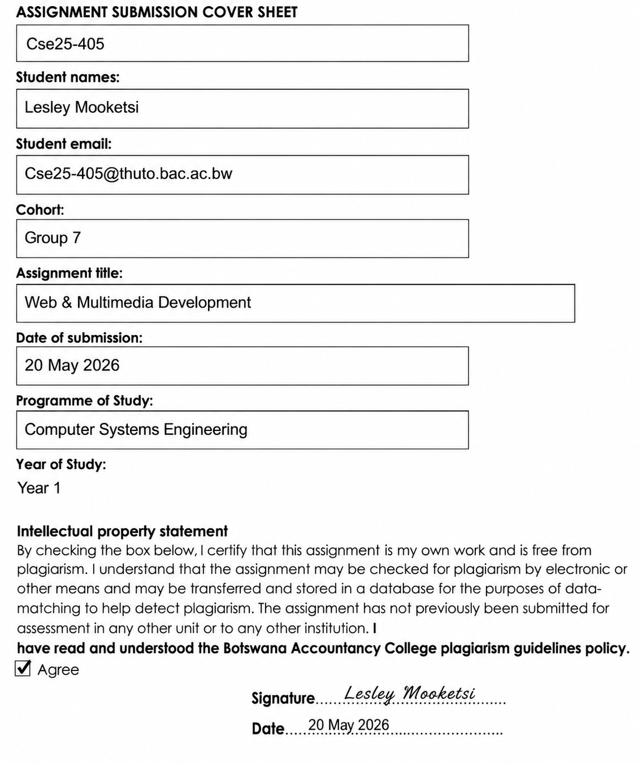

Website Name: Orthodox Western Clothing
Introduction
The Orthodox Western Clothing website is a modern online platform designed to showcase western-inspired fashion. The website focuses on presenting a variety of cowboy-style clothing, including hats, boots, jackets, and jeans.
It is designed with a clean layout and easy navigation to ensure users can explore content comfortably. The platform will also reflect the brand’s identity and style while providing an engaging and visually appealing experience across different devices.

Website Objective
The objective of the Orthodox Western Clothing website is to promote and sell western-style fashion clothing inspired by cowboy culture & designed to establish a strong online presence for the brand, showcase products, and provide customers with an easy and enjoyable shopping experience.
Goals of the Website
1.To display a variety of cowboy clothing (boots, hats, jackets, jeans).
2.To attract and engage customers through appealing visuals and design
3.To increase brand awareness in Botswana and internationally
4.To allow users to browse products and submit inquiries or feedback
5.To create a modern, responsive website accessible on all devices
Target Audience
Age: 18–45
Gender: Male & Female
Location: Botswana + International audience
People interested in western/cowboy culture and fashion.
Farmers/rural communities
Rodeo and outdoor lifestyle enthusiasts
Technical Aptitude:
Basic to intermediate internet users- Users who know how to use the internet for basic activities like browsing websites, using social media, and searching for information.
Familiar with smartphones, social media, and online browsing
Type of Website
The website will be an E-commerce / Brand Showcase Website, focusing on:
- Product display
- Brand identity
- Online shopping simulation
- Customer interaction
- Product category browsing
- Cart and checkout functionality
- Contact and feedback communication

2. Information Design & Taxonomy
Site Map (Structure)
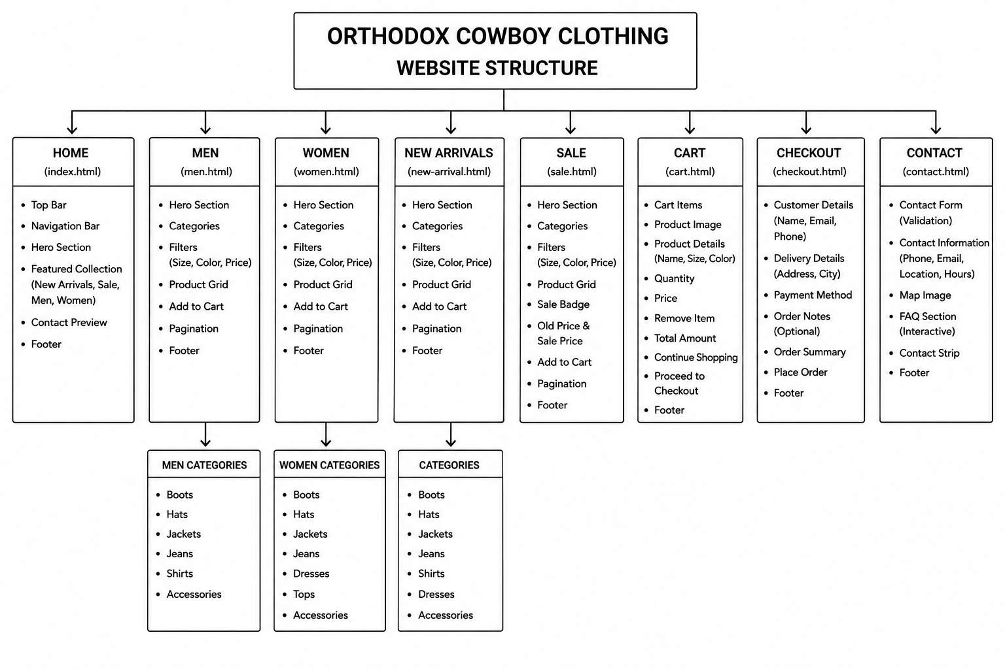
The structure of the website is organized to ensure easy navigation and a smooth user experience.
Main Pages and Structure
Home Page (index.html)
The main landing page that introduces the brand, highlights featured products, and provides navigation to all sections of the website.

Men Page
This section contains all products designed for men. It is divided into:
- Boots
- Hats
- Shirts
- Jeans
Women Page
This section contains all products designed for women. It includes:
- Boots
- Hats
- Dresses
- Jeans
New Arrivals Page
Displays the latest products added to the website to keep users updated with new fashion trends.
Sale Page
Highlights discounted items and special offers to attract customers.
Cart Page
The cart page displays all selected products. It includes:
- Product image
- Product name
- Selected size
- Selected color
- Quantity
- Price
- Total amount
- Remove item button
- Continue Shopping button
- Proceed to Checkout button
This allows users to review their order before checkout.

Checkout Page
The checkout page allows users to enter their order details. It includes:
- First name
- Last name
- Email address
- Phone number
- Delivery address
- City
- Payment method
- Order notes
- Order summary
- Place Order button
The checkout process is simulated using JavaScript. No real payment is processed.

Contact / Feedback Page
Allows users to communicate with the business through a form. Users can send inquiries, feedback, or suggestions.

3. Technical Brief
Technologies to be Used
HTML5 will be used to provide the structure of the website. It defines how content is organised on each page, such as headings, navigation menus, images, and forms. By using semantic elements like header, navigation, and section tags, the website becomes easier to read, maintain, and understand.
CSS3 will be used to control the visual appearance of the website. It is responsible for styling elements such as colours, fonts, spacing, and layout. CSS ensures that the website has a consistent and professional look across all pages while also improving the overall user experience.
Bootstrap will be used to enhance responsiveness and ensure the website is mobile-friendly. It provides pre-designed layouts and components that automatically adjust to different screen sizes, allowing the website to function properly on desktops, tablets, and smartphones without requiring complex custom code.
JavaScript will be used to add interactivity and improve functionality. In this project, it can be applied for form validation to ensure users enter correct information before submitting. It can also be used to enhance user interactions, making the website more dynamic and user-friendly.
4.User Experience Design
The website was designed to be simple, clear, and easy to use. The layout is consistent across all pages to help users understand the structure quickly.
The user experience focuses on:
- Easy navigation
- Clear product display
- Consistent page design
- Responsive layout
- Simple shopping process
- Clear call-to-action buttons
- User-friendly forms
- Visual brand identity

5.Future Improvements
In the future, the website can be improved by adding:
- Real payment integration
- User login and registration
- Admin dashboard for managing products
- Product search bar
- Product reviews and ratings
- Real order database
- Delivery tracking system
- Wishlist feature
- Stock management
- Email confirmation after checkout

4.Page Template
Low fidelity

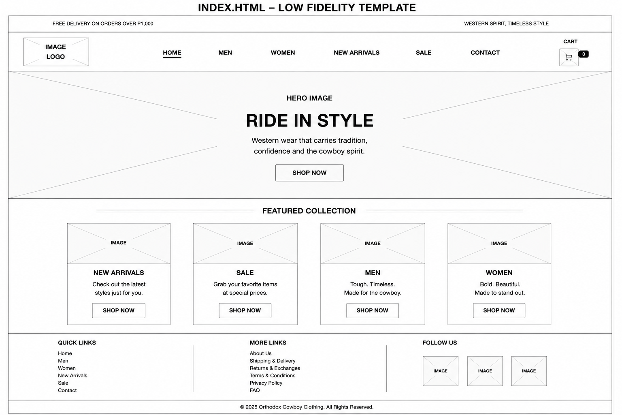
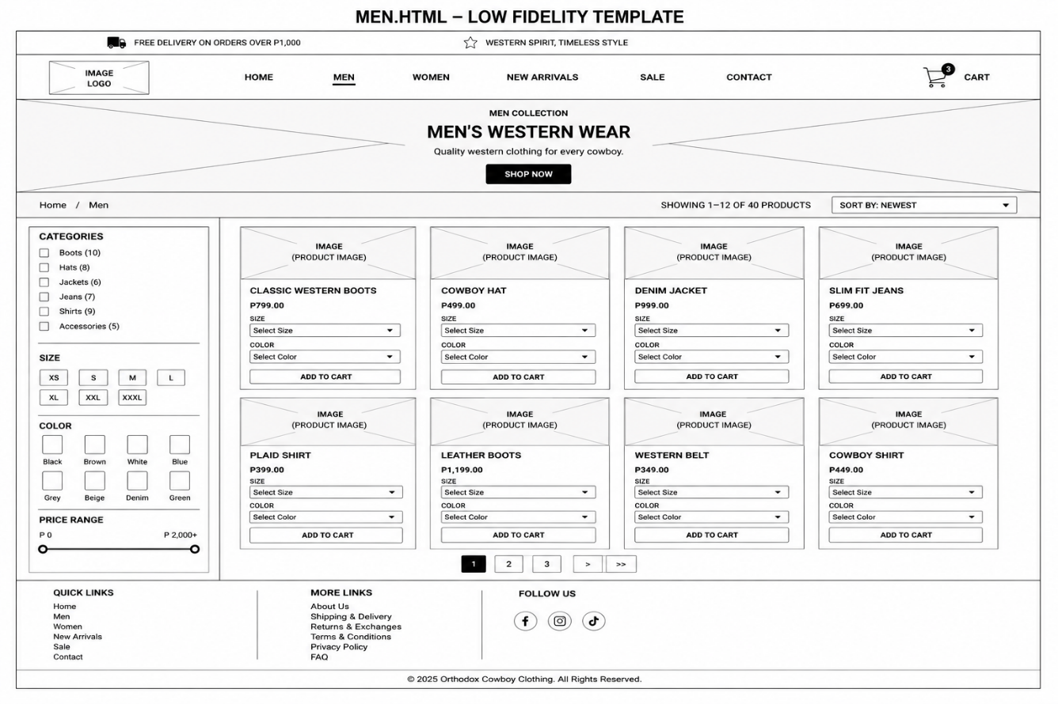
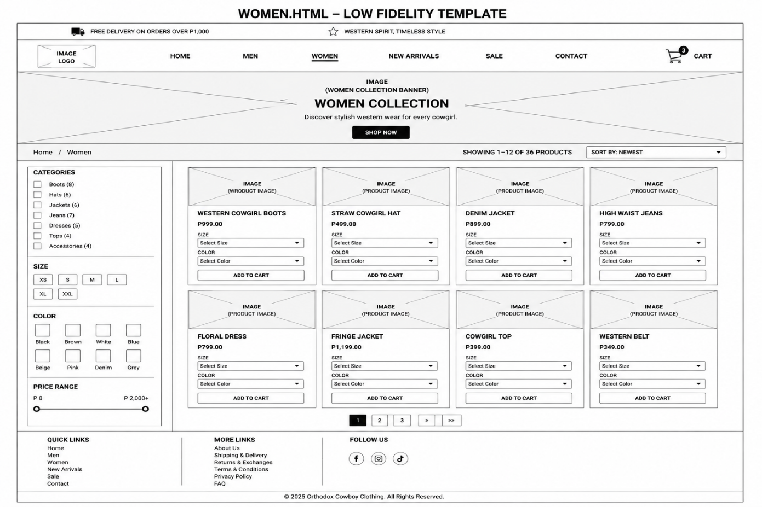

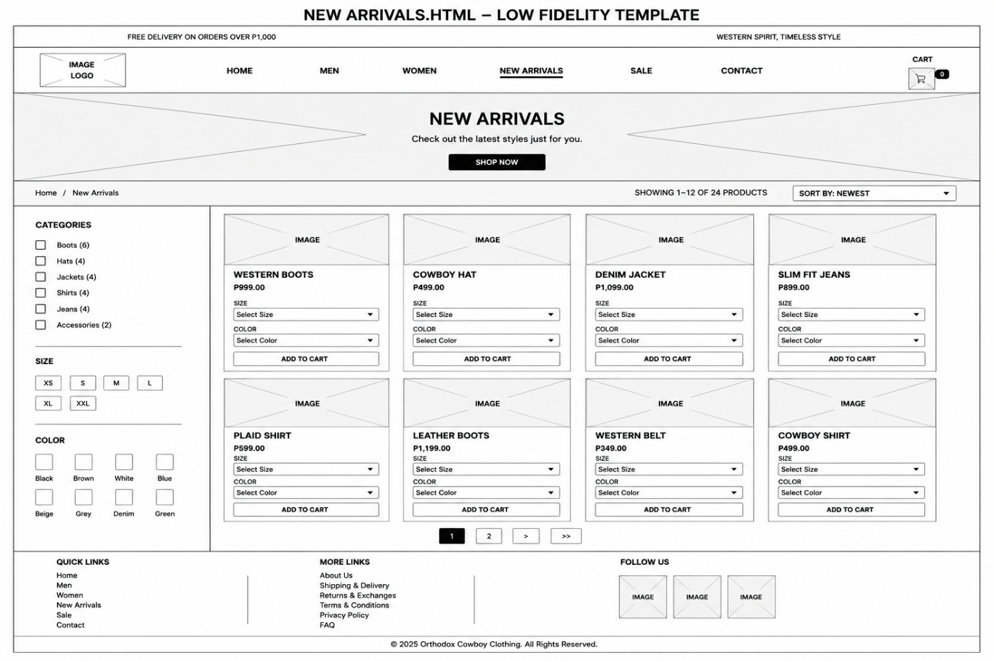

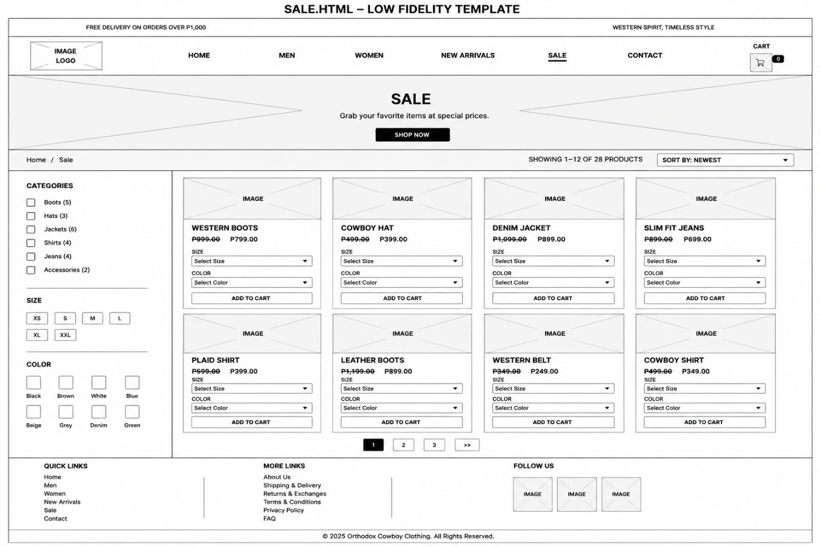

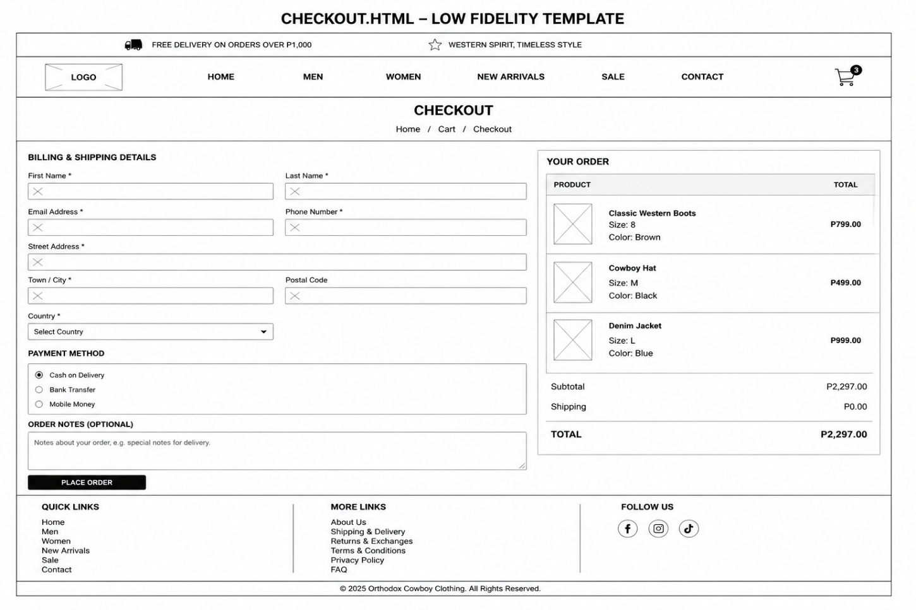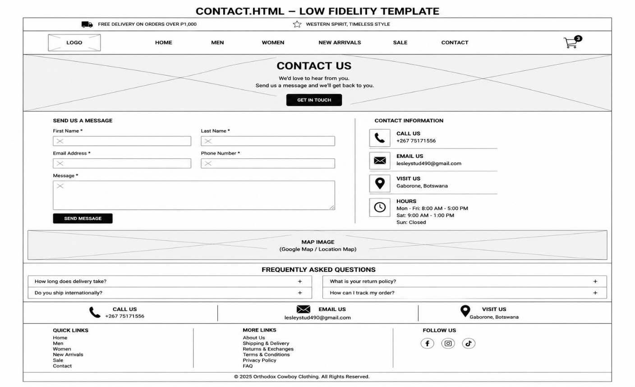
High fidelity 